# Rest and Rest API (V: 3)

Rest is an architectural design guideline where Restful or Rest API is complete API which developed using rest.

# Serializer and Serialization (V: 6)

# Deserialization (V: 8)

# Validation (V: 10)

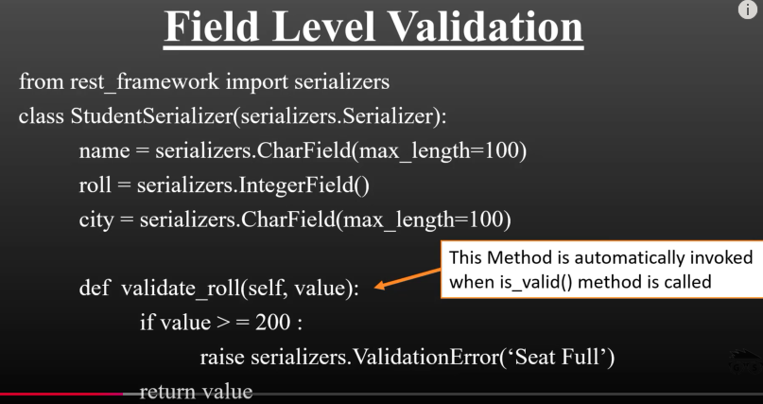

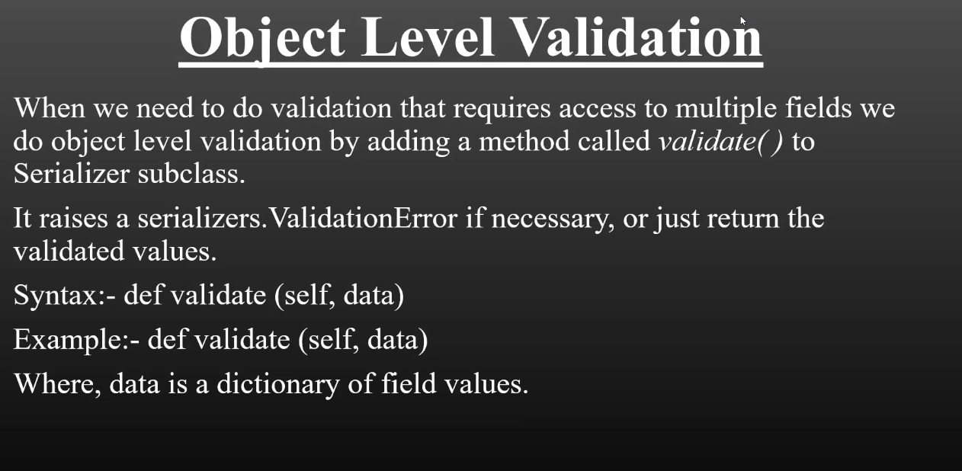

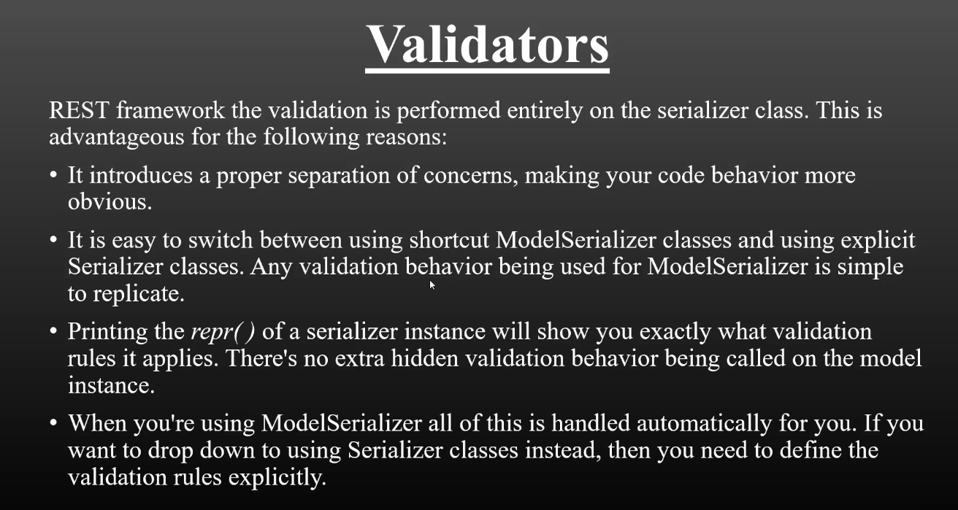

Priority of checking validation (High to Low):

1. Validators
2. Field level validation
3. Object level validation

**Resource:**

<https://www.youtube.com/watch?v=9fB6fPNq6sc&list=PLbGui_ZYuhijTKyrlu-0g5GcP9nUp_HlN&index=10>

# Model Serializer (V: 11)

First one for single value

Second example for Multiple value

Another way of restriction:

* **Validation Process will be same for both ModeSerialization and Serialization**